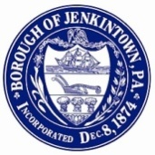
BUILDING, ZONING, & REVITALIZATION COMMITTEE
July 21, 2014
7:30 p.m.
AGENDA

Call to Order

Public Comment

Featured Items for Discussion

- Status report on 204 Wyncote Road
- Other vacant property updates – List of vacant properties and status of each; residential and targeted commercial
- MCPC - Partnership
- Residential Vacant Properties Ordinance

Items for Decision to forward to Full Council

- Zoning Hearing Board - Recommendation for Appointment
- Recognition Award(s) - EisnerAmper Accountants and Advisors

Other Items for Discussion

- PECO 2014 Natural Gas Projects

Items for Information

- Jenkintown Planning Commission
- New businesses; closed businesses; progress re: businesses planning to open

Ongoing items

- Property Maintenance notices
- Lindy Sign Proposals - Piazza
- Facade Grant

Other issues

Adjournment

